Proposal

Grainger
Void Management

Version 1.0
February 21, 2017
Contents
1 Executive Summary 3
1.1 Introduction 3
1.2 The Business Opportunity 3
1.3 The Project 3
1.4 The Business Benefit 3
1.5 The Timeframe 4
1.6 The Cost - Overview 4
1.7 The Relationship 4
2 Proposed Solution 5
2.1 Sample Screens 6
2.2 Solution Context 7
2.3 Future Functionality 8
2.4 Technical Overview 8
2.5 Implementation Approach 10
2.6 Training 10
2.7 Support 10
2.8 Exclusions and Limitations 10
2.9 Assumptions 11
2.10 Prerequisites 11
3 Detailed Costs 12
3.1 Dependencies 14
3.2 Change Management 14
4 Project Methodology & Experience 16
4.1 Project Methodology & Approach 16
5 Next Steps 18
6 Acceptance 19

Executive Summary

Introduction
<Context of proposal>
This proposal has been prepared at the request of Client Name and outlines the development of xyz.

The Business Opportunity
<Summary of business opportunity that is available. Rephrase negative problems as positive opportunities.>

The Project
<Summary of the proposed project>

The Business Benefit
<Business value and benefits that the project will provide. These are the criteria against which the project’s success will be measured (i.e. key success factors). Try to identify measurable benefits such as client benchmarks where possible.>
- <E.g. improved efficiency / time savings / reduced resources / faster turnaround; reduced cost / financial savings; reduction in errors; lower risk; improved security; mobility / accessibility; greater data integrity / data quality; improved user experience; legal compliance; improved competitive advantage / product marketability; improved management visibility / transparency / traceability; leverage existing data / functionality; reduce dependency on third party; standardizing processes; greater control>

The Timeframe
The expected timeframe for delivery of the project is as follows:
- Requirements Analysis: x weeks from proposal sign-off
- Design: x weeks from requirements sign-off
- Development & Testing: x months from design sign-off
- UAT: x weeks
- Go-Live: [Month YYYY] (assuming project approval by [date])
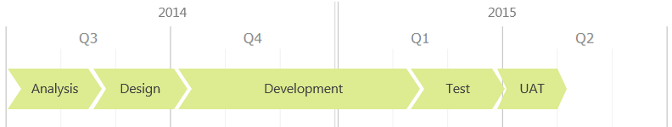
This proposal is valid for [thirty (30) days].

The Cost - Overview
The cost of the proposed project is estimated to be £x to £y excluding VAT, if applicable.
Further details may be found within the Detailed Costs section.

The Relationship
Open Box will assign a dedicated Grainger account manager who will be responsible for managing the long-term relationship and building a Grainger knowledge-base which may be applied to future projects. The manager will also bring with a solid foundation of experience working with other real estate companies.

Proposed Solution
<Detail the proposed solution. Establish the scope of the project, major objectives to be addressed, key features and deliverables.>
<Reference latest documentation if completed, if any. Otherwise this section should be very detailed>
[The following should be read in conjunction with the [latest documentation] document dated [date] delivered to Grainger.]
Open Box proposes to deliver an online leasing module – Prospect Connect – that will be available as an optional module to MRI Residential Management SaaS customers.
The solution will address the following objectives:
- Online Payment – Payment of the application fee is authorized using a credit card.
  - Where authorization is successful, the apartment is temporarily reserved for the applicant.
  - Reservations are automatically cancelled if the online application is subsequently abandoned.

Sample Screens

Figure 2: Sample Screen – Description

Solution Context
The following provides an overview of the solution’s interfaces:
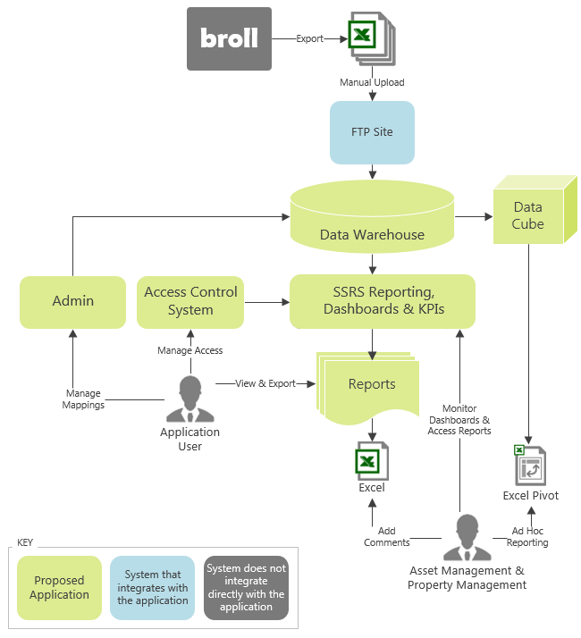
Figure 6: Proposed Solution Context
- Key Element in Context Diagram – Detail

Future Functionality
Additional functionality that is not included in the initial project scope as outlined above, but which may be addressed in future project releases includes:
- Reports – The remaining reports from the supplemental reports pack may be added to the SSRS reporting platform.

Technical Overview
<Where appropriate, include high-level points on the technical solution that will be built – what technologies used and what it will run on (applications, systems, OS etc.). Ensure that it is fluid enough to give options when we get to the design stage, but scope out complex technologies e.g. run on IE 6.0 on XP not IE 6.0 on PDA etc.>
<High-level components e.g. mobile platform, web platform, web API, business layer, database, access control system>
<Third party tools e.g. augmented reality, CAD, PDF annotation, handwriting recognition>
<Security overview>
<Hosting requirements e.g. server environments, networking requirements>
<Backup and recovery>
The proposed inspection tool will consist of native iOS and Android mobile apps and a companion web-based interface which share a common back-end. The mobile apps will synchronize data with the back-end via a web API. The web components and database back-end will be built and hosted on the Microsoft technology stack.
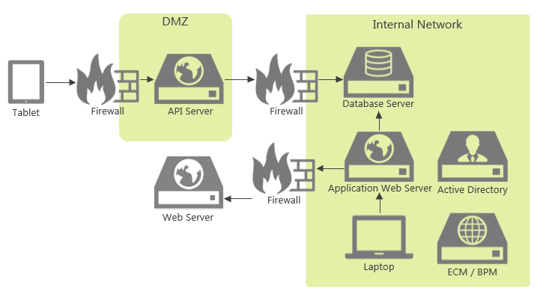
Figure 7: Proposed Infrastructure Diagram
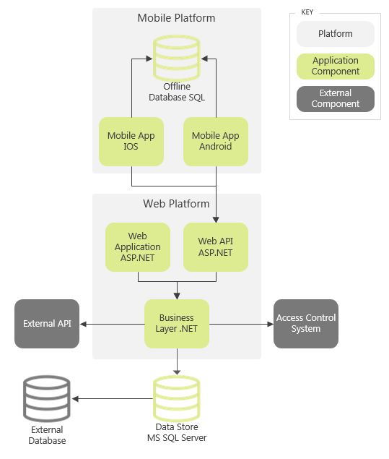
Figure 8: Proposed Architecture Diagram

Implementation Approach
<Discuss any proposed phasing where applicable>

Training
To facilitate the training process, Open Box will train a designated Grainger representative. / Open Box will not be required to do end user training or develop any training materials. /End user training and the development of training materials will be the responsibility of Grainger. Open Box will provide [16 hours] of technical consultation time to assist Grainger with this process. / Open Box will deliver a training manual detailing the high level functionality of the solution to assist the end user when using the solution.
[Where Grainger plans to perform further in-depth training to increase user adoption and requires additional training consultation time from Open Box, this effort will be billed on a time and materials basis.]

Support
Open Box Software will provide [40 hours] of offsite, weekday support within the [first month] after the application goes live. / The project cost does not include ongoing support and maintenance of the solution.
Additional support may be made available through a separate support and maintenance contract, should this be deemed necessary. Open Box has a number of support models available.

Exclusions and Limitations
In order to right-size the proposed project, certain functionality will be excluded. The following is not included in the cost or scope of this project:
- The following functionality will not be included in the initial project, but may be addressed in subsequent releases:
  - <Nice-to-have functionality>
- <Exclusions and limitations of proposed project>
- The user interface will not support multiple languages.
- The ability to create or maintain report templates is beyond the scope of this proposal.
- The web application will not be developed with a responsive user interface for use on mobile devices.

Assumptions
The following assumptions have been made; incorrect assumptions may affect project cost and timelines.
- <Assumptions regarding project nature and scope>
- Client Reports to be made available in Word and Excel format.
- The chosen reporting platform must be compatible with Azure cloud-based services.
- No data migration is required as part of the project.
- The system will integrate with Client Name’s Active Directory.
- The system will be designed and optimised for use with [Chrome].
- Standard buttons will be used, dependent on the third-party dashboard tool selected.

Prerequisites
To enable Open Box to deliver the items above, Grainger will need to deliver the following in a timely manner. / Before commencing [the project], Grainger will need to supply the following:
- <List project and technology dependencies>
- Should Client Name have specific project management requirements for the project, these should be identified and agreed upon with Open Box prior to project commencement.
- Remote access to all servers and terminals that will use the system.
- Access to relevant development and UAT environments.

Detailed Costs
<T&M>
This project will be billed monthly, on a time and materials basis at a rate of $x per hour/ Rx per hour, excluding sales tax.
It is expected that the project duration will be approximately x to y days/weeks of effort if a x% allowance for unidentified requirements is applied. Thus the total cost of the project is estimated to be $x to $y/Rx to Ry, excluding sales tax.
Cost will be reported to Grainger on a [weekly basis/in the weekly project management report] during the course of the project. [The cost will not exceed the upper limit of $z/Ry without prior consultation.]
<FTE>
The project will be billed monthly, on an FTE basis.
- “FTE” is defined as 160 hours per month.
- One FTE may be made up of more than one Open Box member of staff through the duration of each month.
- Unused time will not automatically roll over into the following month.
The project is expected should consume x to y full time equivalent (FTE) resources over a duration of x to y weeks if a x% allowance for unidentified requirements is applied. The total estimated cost is $x to $y/Rx to Ry, excluding sales tax.
[By the [15th] of each month, Open Box will deliver to Grainger a forecast of the required FTEs for the following month.
- By the [20th] of each month Open Box and Grainger will agree on the number of FTEs to be allocated for the following month.
- This agreement will be binding on both parties for the following month and will be invoiced by Open Box at the end of the following month.
OR: The agreement will be automatically renewed on a monthly basis, with one prior month’s notice to be given, by either party, of the intention not to renew.
- Grainger should communicate any requests for additional FTEs by the [15th] of the month, to be made available at the beginning of the following calendar month.
  - Open Box will make every effort to provide additional resources where requested, however this will be subject to resource availability.
- Grainger will provide [one prior month’s] notice of the intention to reduce the number of FTEs required.
- Costs will be billed monthly, in arrears. ]
<All Projects>
Open Box will endeavor to commence work within [2 weeks] of receiving sign-off, contingent on operational factors.
The cost includes:
- Requirements analysis and design
- [Graphic design]
- Development
- Testing [and automated tests]
- [Documentation]
- Deployment to Grainger’s staging and live environments
- [40 hours] post-implementation support
The above cost does not include:
- Any third-party costs, license fees, subscriptions or services
- Hardware and infrastructure
- Support and maintenance
- Travel and subsistence
  - Should onsite personnel be required, any related expenses will be reimbursed by Grainger. Grainger shall be notified prior to, and give approval for, any expenses being incurred. [A cap of 10% of the value of the project shall not be exceeded for additional project expenditure that falls into this category.] [These expenses will be payable on invoice throughout the project.]
- Additional exclusions as agreed upon in the User Requirements Definition or Functional Specification documents and their amendments

Dependencies
A final estimate of cost and timeline will be delivered on completion of the Functional Specification phase of the analysis.
Regular updates regarding any significant changes in scope or cost will be delivered to Grainger as and when they occur.
Costs and timelines are contingent on:
- <List non-functional assumptions regarding costing & duration. Do not repeat functional assumptions from above.>
- Prompt review, feedback and sign-off of project documentation by Grainger.
- [Grainger delivering the required new website content (text, images, PDF documents, etc.) in a timely manner.]
- Grainger is responsible for the configuration and stability of the UAT/staging and live environments (hardware, operating system and supporting applications).
- Completion of UAT by Grainger within a [x-week] timeframe. UAT will be assumed to be complete if no feedback has been received within [15 days] of the deployment to the test environment.
- Grainger making the necessary resources available, as and when required, ensuring no delays occur through the various phases. Timing commitments cannot be guaranteed by Open Box if resources are not made available to the project.
- There are no other projects planned or in operation that may hinder this project.

Change Management
Should any of the assumptions, exclusions or dependencies as agreed upon during the duration of the project change in any way that might affect the project timeframe and costing, Open Box reserves the right to renegotiate the cost of the project via the Change Management process.
Additionally, any requests for additional work, beyond the agreed scope of the project and the agreed design will be managed via a change control process. Such changes may incur additional cost and may affect the project timelines.
Change requests shall be brought before the Grainger and Open Box project managers for discussion and decision on whether the change should be included as part of the implementation. Any changes that require additional resources or time for the project will require approval by the Grainger project manager prior to work commencing on the change.

Project Methodology & Experience

Project Methodology & Approach
The following diagram outlines the high-level project and review process.
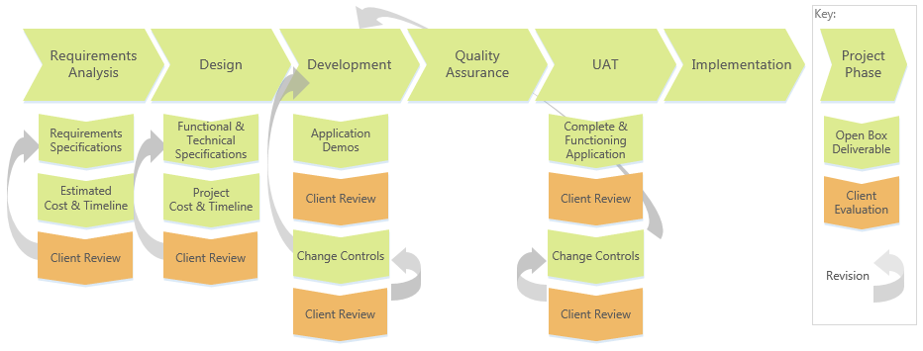
Figure 9: Open Box Project & Evaluation Process
- Requirements Analysis – Open Box will assess the application requirements through consultation with Grainger.
  - All requirements which the application must address will be documented by Open Box in a User Requirements Specification which will be reviewed and signed off by Grainger.
  - Updated costs and timeline estimates will be provided on completion of the requirements analysis.
- Design – Open Box will document the application design in the Functional [and Technical] Specifications which are reviewed and signed off by Grainger.
  - The project cost and timeline will be finalised on approval of the application design.
- Development – Open Box will develop and test the application and will periodically demonstrate project progress to Grainger.
- UAT – Grainger will be responsible for conducting user acceptance testing (UAT).
- Change Controls - Any changes to the approved design will be managed through a change control process.
  - Change requests may arise from Grainger feedback during application demonstrations or during UAT.
  - Each change will be documented by Open Box in a Change Control document which is reviewed by Grainger. Grainger may approve or reject a change control, or defer the change for a subsequent application release.
  - Change controls will incur additional project cost and/or affect project timelines.

Next Steps
The proposed next steps are:
- Grainger to approve the proposal.
- Grainger to sign the Open Box Master Services Agreement.
- Grainger to provide the requested prerequisites.
- Information / access client must provide.
- Information Open Box must provide. E.g.:
  - Open Box to make recommendations on a content management system as well as hosting environment.
  - Open Box to provide design samples for review.
- Demos to Client of similar systems.
- Open Box to complete requirements analysis and provide an updated cost estimate.
If there are any queries on the content in this proposal, please do not hesitate to contact xxx.

Acceptance
[This proposal is concluded in terms of the Master Service Agreement for Consulting Services between the parties (dated [xxxx]) (“MSA"). The services recorded in this proposal will be governed by the terms of this proposal as read together with the MSA.]
The parties hereto, each acting under due and proper authority, have executed this Agreement as of the day, month and year first written below.

For and on behalf of Open Box Software For and on behalf of Grainger

Signature: _____________________ Signature: _____________________
Name: _____________________ Name: [Client Contact Name]
Position: _____________________ Position: [Position]

Date: _____________________ Date: _____________________

